**Shri G.S. Institute of technology and Science**

(An Autonomous Institute, Established in 1952)

**LABORATORY ASSIGNMENT**

**CT10705: Computer Networks**

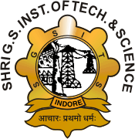

**Department of Information Technology and Application**

**2024-26**

**MCA I YEAR**

**Semester – II**

**SUBMITED TO: SUBMITTED BY:**

**Mr. Deepesh Agarwal SHIV ARORA**

**Ms. Sukanya Sinha**

**Ms. Megha Rathor**